High Performance, High Cost

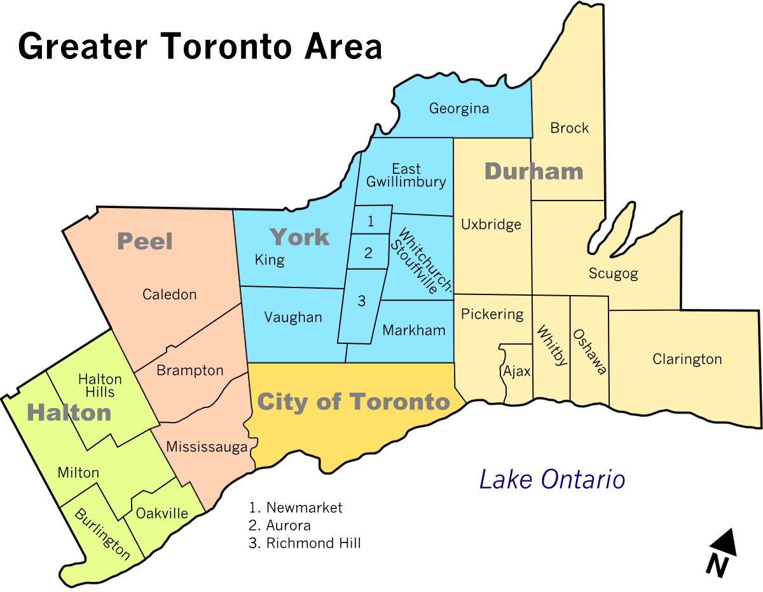

Student Name
Course Code
Date

Ways to lower the price of fuel for a performance car for car owners in Toronto City, Ontario
Problem or HMW Statement- The extent of the problem is very alarming and going by the rate at which the car owners of the high-performance vehicle are choosing to explore alternative fuel for their cars makes the choice suitable. I strongly avow that there is need to regulate the inflated prices of fuel in the city. Taxation laws and premium charges on fuel by the gas companies is exorbitant and it is important for finding ways to lower these prices. Track drivers and other owners of high performance cars in the area have been subjected to unfairly high prices even than food and other basic household goods.

Value Proposition - The value proposition includes changing the corporate cultural values of fuel companies by introducing discounted prices for the High performance car owners, Track Drivers and Logistic Freight Companies customer segments. Also, offering subsidized engine checkup at the retail outlets will help to ensure that the consumption patterns for the cars is at optimum levels to avoid fuel wastage in the engines.

Section 1: HMW and POV Change Rationale:

In part, the decision to change the rationale and include high performance tracks and car was informed by the fact that selected location population was mainly composed of car owners with high performance capacity and track owners. Consultation with the gas station attendants revealed that these groups were the most affected by the high fuel prices in the area. Thus, in the Value creation process, it was plausible to focus more on lowering prices for this group because they constituted the group of the highest consumers of fuel in the city.

Section 2 – Value Proposition

I chose the high performance car owners, track drivers and Logistics Freight companies because after consulting with the gas attendants of several fuel retail outlets, I discovered that they complained the most about the exorbitant prices of fuel. The other consumer segments did not express any concerns to the pump attendants. Therefore, given these findings the population segment seemed the most suitable group to focus on for the exercise. It influenced my value statement because in that the focus shifted to affordability and productivity of the customer segments as the core value propositions.

For the High Performance Car owners, the high cost of transport and maintenance was the greatest pain because it affected their ability to use their cars to meet their daily needs. Increased fuel consumption was the biggest gain because it translated to increased efficiency to accomplish their day to day movement needs.

For the track drivers and logistic freight companies, high fuel prices translated to high cost of production for their services which in my view was their great pain. With low fuel prices, increased productivity was considered the greatest gain because the customer segments were able to meet their revenue targets.

Section 3 – Global Location Analysis
Toronto area in Ontario region of Canada has the highest fuel prices in North America. I chose this international foreign location because the citizens in the country are concerned largely about the fuel prices of performance cars. In the region, the car owners are highly concerned about the prices of fuel and the possible ways that the issue may be addressed. It is also a unique city because the statistics show the high prices of gas are causing many car owners to shift to electric cars that are easier and cheaper to maintain (Morgan). Secondly, the extent of lobby initiatives by the car owners to lower the price-tax of gas is very in Toronto. The profit margins of fuel are among the highest in the world which made the area suitable. Also, the value proposition in the area will be very high because it will impact several aspects of the car owners in the area

Appendix I - Value Proposition Table

Value Proposition Table
Customer Segment.  ● Track Drivers  ● Owners of High Performance cars | Jobs (To Be Done) for the chosen Customer Segment  HIGH PERFORMANCE CAR OWNERS  ● Discounted prices of the premium fuel  ● Regular free engine check up by gas stations mechanics for premium customers  TRACK DRIVERS  ● Discounted prices of the premium fuel  ● Regular free engine check up by gas stations mechanics for premium customers
What are the Greatest pains for customer segment  HIGH PERFORMANCE CAR OWNERS  PREMIUM FUEL  • High cost of vehicle maintenance  • High transportation costs for trips  • Low fuel consumption  TRACK DRIVERS OWNERS AND LOGISTICS FREIGHT COMPANIES  ● High cost of production margin  ● Low profit margins of the selected groups  ● | What are the Greatest Gains for the customer segment  HIGH PERFORMANCE CAR OWNERS  • Low cost of vehicle maintenance  • Increased quality of life due to surplus expenditure  ● Affordable fuel cost  Track Drivers and Logistics Companies  ● Low cost of production  ● Increased profit margin from shipment ventures

Appendix II World Locations



APPENDIX 3 World Location Detail

WORK CITED

Morgan, G. "'It's going to be felt at the pump': Ontario could see gas price hikes if Enbridge's line 5 stays shut." financialpost, 2020, financialpost.com/commodities/energy/its-going-to-be-felt-at-the-pump-ontario-could-see-gas-price-hikes-if-enbridges-line-5-stays-shut.

